Mellor Church Choir Report 2024 *Tom Howling*

I mentioned in my 2023 report that with expanded numbers in the choir, the church was looking at creating a flexible seating area between the choir stalls and the nave pews to more comfortably fit the full choir in. Planning for this remains ongoing.

We have continued to be able to recruit into the choir – especially new children using our regular ‘pizza open-rehearsal’ initiative.

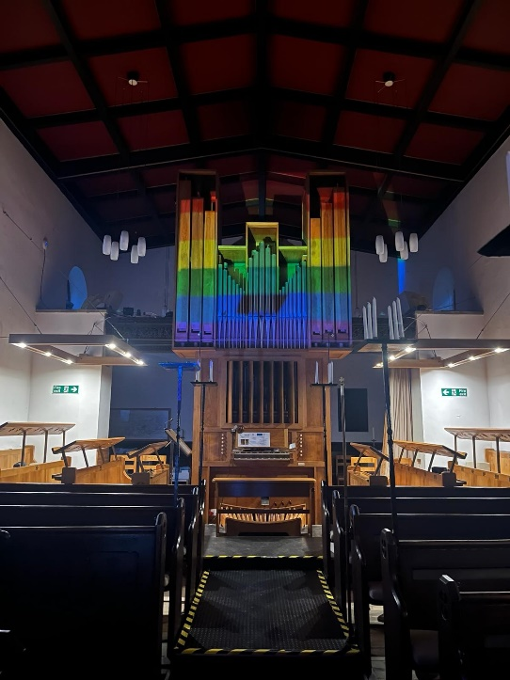In 2024 we continued our program of training for the **RSCM Voice for Life** awards. The training sessions took place on Saturdays in early 2024 leading to the examination day, hosted in Mellor for the whole of the Northwest region.

Congratulations to Kate Higgins, Oscar Qualter, Katya Horokova, George Maxwell, Ellie Britton and Olivia Kayes who all successfully completed their Bronze Awards. Congratulations also to Eleanor Rosser who was awarded a Gold Award in a special national Royal School of Church Music service in St Alban’ Cathedral. Thank you to the Moorend Trust for supporting this training program.

We enjoyed a series of themed monthly choral evensongs which included one to mark **LGBTQ+ History Month in February** and the annual outside evensong in July celebrating **200 years of the RNLI**. This year we were blessed by fair weather and a memorable talk by our organist and former RNLI volunteer, John LeGrove.

The choir was busy in April with our usual Passiontide and Easter services which included a **Cross of Christ** service on Passion Sunday.

There was an unofficial hill-top rendezvous for many members of the choir in May when the North Lights were clearly visible over Mellor.

The most impressive venue for the choir in 2024 was **Truro Cathedral** where we spent a week in the summer as the ‘choir in residence’ singing a total of six services. We had a wonderful week with beautiful weather in Cornwall. Highlights included visiting beaches to swim in the sea, parkrun at Trelissick, visit to the Eden Project, evenings playing games on the lawn of the school where we stayed, cliff path walking, a party night and the choir cabaret evening. Thanks must go to our fantastic team of organists (John, Nathan and Eleanor) who got to play on two wonderful organs in the cathedral and Kate Scott for organising the accommodation at Truro High School for Girls which was walking distance from the cathedral and served us all with excellent food.

In September, the choir took part in the **Festival of Choirs** at St. George’s church in New Mills. It was great to see a strong representation from our church, both in the choir and congregation at that occasion which included singers from choirs from across Derbyshire.

In November, the choir put on a **Remembrance Concert** which included Fauré’s *Requiem* and a selection of seasonal reflective music themed around *Crossing the Bar*. This was again well attended, and funds were raised to support the church.

We had a record attendance at **Fort Belan** near Caernarfon for the rehearsal weekend where we prepare the music for Advent and Christmas. As well as lots of hard work, we had lots of fun including the inevitable cabaret which was the best ever this year. Thank you to Rachel Howling for organising the rooming of choristers creatively.

December is always a busy time for the choir and despite the cancellation of Winter Wonderland we had a record amount of **carolling events**. We sang carols at the Dark Peak Vineyard, Thornsett Brewery and Oddfellows Arms raising £360 in total for The Wellspring. The **Advent Carol Service** and **Nine Lessons and Carols Service** are highlights of the choir year and both went very well. A group of people sitting on the floor
Fun was had at the annual **Christmas Party** which follows the carol service.

**Midnight Mass** was quieter in mood following all the frantic festive activities. The service featured Haydn’s Little Organ Mass.

**Christmas Morning** service featured more jolly carols, a sleigh ride, and a rendition of *We wish you a Merry Christmas* with our returning former choristers.

We greatly appreciate our team of **organists** – John LeGrove, Nathan Monk and Eleanor Rosser who greatly support and enhance the work of the choir and musical ministry of Mellor Church.

The **Vocal Development Group** for primary school age choristers has continued this year, developing their musical skills and confidence. Thank you to John LeGrove for continuing to spearhead this initiative.

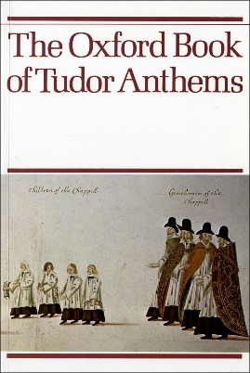An innovation in 2024 has been to add an optional 30mins onto choir practice on Fridays for those who would like to try singing more challenging polyphonic music. The **Tudor Anthems Group** has proved popular with the more experienced and discerning choristers and has been helping to develop independent sight-reading skills in the choir.

I would like to thank Andrew, our vicar, and the PCC for supporting the choir. I would also like to thank the Choir Steering Group (CSG), choir members and parents of choristers for continuing to show their support.

We have a lot to look forward to in 2025 including a **choir tour to Barcelona** (27th – 31st July). Do come and see us if you can.