Psalm 88
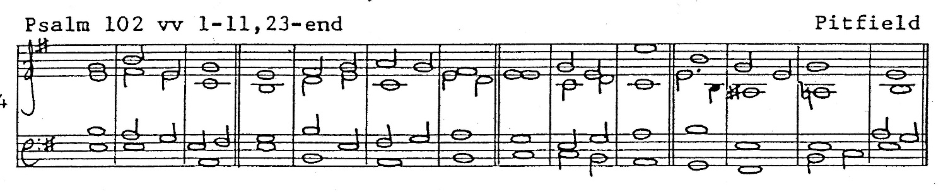

1 O Lord my God I call for | help by | day:
and by | night I | cry to | thee.

2 O let my prayer enter | into thy | presence:
incline thine | ear | unto • my | calling.

3 For my soul is | full of | trouble:
and my life | draweth | nigh • to the | grave.

4 I am counted among them that go down | into the | pit:
and I am even as a | man that | hath no | strength.

5 I am become like unto the dead *
and unto the slain that | lie • in the | grave:
whom thou rememberest no more, *
for they are | cut off | from thy | help.

6 Thou hast laid me in the | lowest | pit:
in a place of | darkness and | in the | depths.

7 Thine indignation lieth | hard up- | on me:
and thou hast over-| whelmed me • with | all thy | waves.

8 Thou hast put my friends far from me, *
and made me to be ab-| horred | of them:
I am so fast in prison that I | cannot | get | forth.

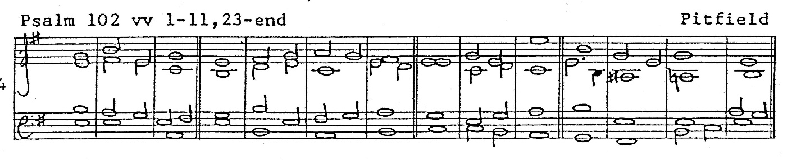

9 My sight faileth for | very | trouble:
Lord I have called upon thee all the day long, *
I have stretched | forth my | hands un-to | thee.

10 Dost thou work wonders | for the | dead:
or shall the dead rise | up a-| gain and | praise thee?

11 Shall thy loving-kindness be | told • in the | grave:
or thy faithfulness | in the | pit • of de-| struction?

12 Shall thy wondrous works be | known • in the | dark:
and thy righteousness in the land where | all things | are for-| gotten?

13 Unto thee I | cry O | Lord:
and early doth my | prayer | come be-| fore thee.

14 Lord why dost thou | cast me | off:
why hidest | thou thy | face | from me?

15 From my youth up I have been in misery *
and at the | point to | die:
the dread of thee have I suffered | with a | troubled | mind.

16 Thy wrathful displeasure | hath gone | over me:
and thy | terrors | have un-| done me.

17 They came round about me like water | all the • day | long:
and compassed me a-| bout on | every | side.

18 Lovers and friends hast thou | put a-| way from me:
and withheld my com-| panions | from my | sight.

Glory be to the Father,* and | to the | Son,
and | to the | Ho-ly | Ghost.
As it was in the beginning,* is now and | ever | shall be:
World without | end.* | A | - | men.

